Practical 2
Linux Commands - Exploring Raspbian
Operating System

1. Basic File & Directory Commands
man
Shows manual/help for any command.
Example:
man ls

ls
Lists files in the current directory.
Examples:
ls
ls -l → detailed list
ls -a → show hidden files

cd
Changes directory.
Examples:
cd Desktop
cd .. → go back
cd /home/pi → go to absolute path

pwd
Shows current directory path.
Example:
pwd

mkdir
Creates a new folder.
Example:
mkdir project

rmdir
Removes empty directory.
Example:
rmdir myfolder

rm
Deletes files or folders.
⚠️ Be careful—no recycle bin!
Examples:
rm file.txt
rm -r foldername → delete folder & inside files

cp
Copies files.
Examples:
cp a.txt b.txt
cp -r folder1 folder2 → copy folder

mv
Moves or renames.
Examples:
mv old.txt new.txt (rename)
mv file.txt /home/pi/Desktop (move)

touch
Creates an empty file or updates time.
Example:
touch notes.txt

cat
Displays file content.
Example:
cat file.txt

head
Shows first 10 lines of file.
Example:
head logfile.txt

tail
Shows last 10 lines of file.
Example:
tail logfile.txt
tail -f logfile.txt → live updates

chmod
Changes file permissions.
Example:
chmod +x script.sh → make file executable

2. SSH & System Commands
ssh
Connect to another machine.
Example:
ssh pi@192.168.1.10

df
Shows disk usage.
Example:
df -h → human readable

dd
Used to copy disks/USB/SD card.
⚠️ Dangerous if wrong path!
Example:
dd if=/dev/sda of=backup.img

tree
Shows folder structure like a tree.
Example:
tree

zip
Compress files.
Examples:
zip files.zip file1 file2
zip -r folder.zip foldername

unzip
Extract zip.
Example:
unzip files.zip

tar
Make or extract .tar / .tar.gz files.
Create:
tar -czvf backup.tar.gz folder/
Extract:
tar -xzvf backup.tar.gz

3. Searching Commands
search
Raspberry Pi doesn’t usually have a search command.
You probably mean find or grep.

grep
Search text inside files.
Example:
grep "error" logfile.txt

awk
Processes text line-by-line.
Example:
awk '{print $1}' data.txt → prints first column

find
Search for files by name.
Examples:
find . -name "*.txt"
find / -type f -size +10M → files bigger than 10MB

whereis
Shows locations of commands.
Example:
whereis python3

4. Networking Commands
ping
Checks if a device is reachable.
Example:
ping google.com

hostname
Shows device name.
Example:
hostname

ifconfig
Shows IP address & network info.
Example:
ifconfig
(On some Pi versions, you might need to install it:
sudo apt install net-tools)

1. Basic File & Directory Commands
1. man
Description: Shows manual/help for any command.
Example: man ls
📸 Screenshot:
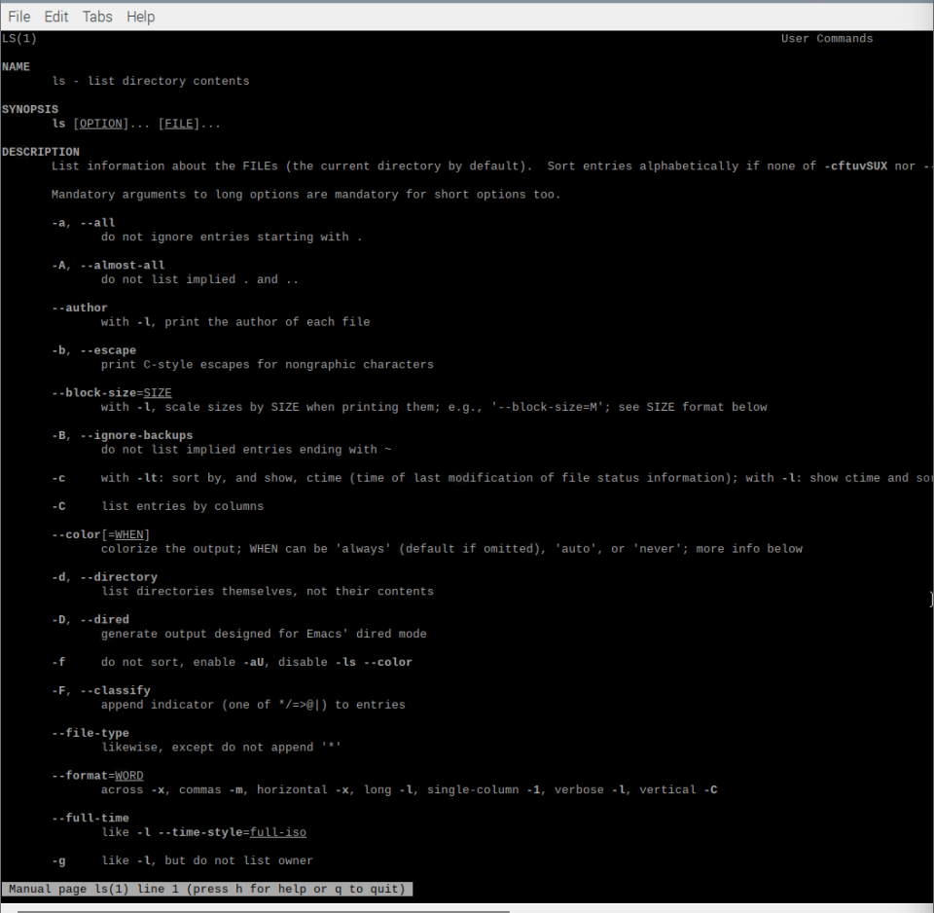

2. ls
Description: Lists files in the current directory.
Examples:
ls
ls -l → detailed list
ls -a → show hidden files
📸 Screenshot:
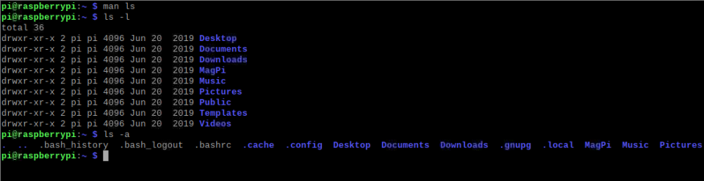

3. cd
Description: Changes directory.
Examples:
cd Desktop
cd ..
cd /home/pi
📸 Screenshot:
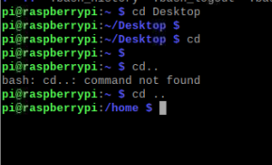

4. pwd
Description: Shows current directory path.
Example: pwd
📸 Screenshot:
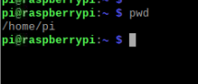

5. mkdir
Description: Creates a new folder.
Example: mkdir project
📸 Screenshot:
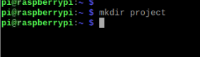
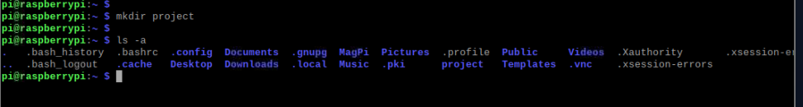

6. rmdir
Description: Removes empty directory.
Example: rmdir myfolder
📸 Screenshot:
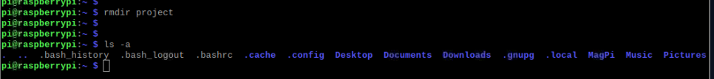

7. rm
Description: Deletes files or folders.
Examples:
rm file.txt
rm -r foldername
📸 Screenshot:
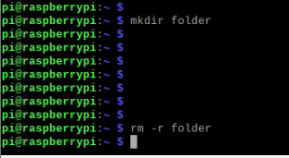

8. cp
Description: Copies files or directories.
Examples:
cp a.txt b.txt
cp -r folder1 folder2
📸 Screenshot:
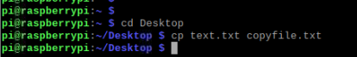
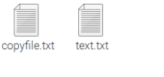
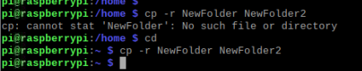
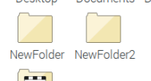

9. mv
Description: Moves or renames files.
Examples:
mv old.txt new.txt
mv file.txt /home/pi/Desktop
📸 Screenshot:
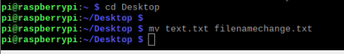 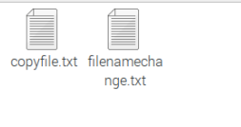

10. touch
Description: Creates an empty file.
Example: touch notes.txt
📸 Screenshot:
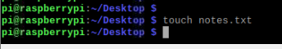 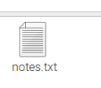

11. cat
Description: Displays file content.
Example: cat file.txt
📸 Screenshot:
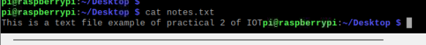

12. head
Description: Shows first 10 lines of a file.
Example: head logfile.txt
📸 Screenshot:
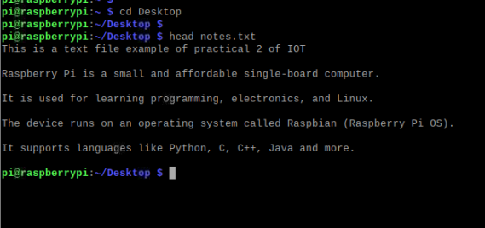

13. tail
Description: Shows last 10 lines of a file.
Examples:
tail logfile.txt
tail -f logfile.txt
📸 Screenshot:
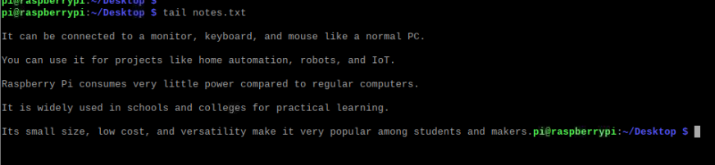 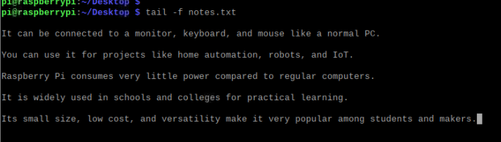

14. chmod
Description: Changes file permissions.
Example: chmod +x script.sh
📸 Screenshot:
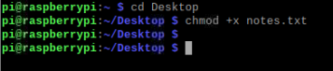

2. SSH & System Commands

15. ssh
Description: Connects to another machine.
Example: ssh pi@192.168.1.10
📸 Screenshot:
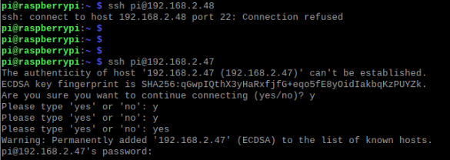

16. df
Description: Shows disk usage.
Example: df -h
📸 Screenshot:
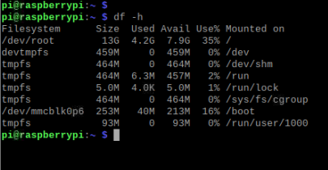
17. dd
Description: Copy disks/USB/SD card.
Example: dd if=/dev/sda of=backup.img
📸 Screenshot:
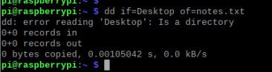
18. tree
Description: Shows folder structure.
Example: tree
📸 Screenshot:
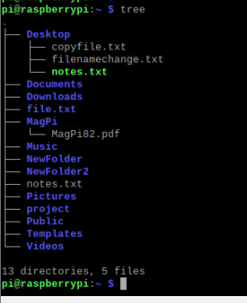

19. zip
Description: Compress files.
Example:
zip files.zip file1 file2
zip -r folder.zip foldername
📸 Screenshot:
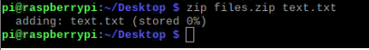

20. unzip
Description: Extract zip files.
Example: unzip files.zip
📸 Screenshot:
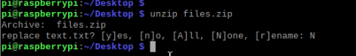

21. tar
Description: Create or extract tar files.
Create: tar -czvf backup.tar.gz folder/
Extract: tar -xzvf backup.tar.gz
📸 Screenshot:
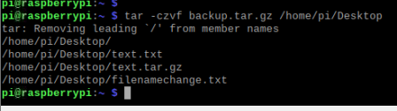
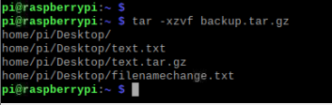

3. Searching Commands

22. grep
Description: Search text inside files.
Example: grep "error" logfile.txt
📸 Screenshot:
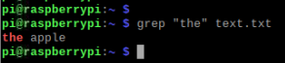

23. awk
Description: Processes text line-by-line.
Example: awk '{print $1}' data.txt
📸 Screenshot:
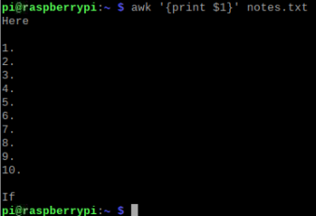

24. find
Description: Search for files by name.
Examples:
find . -name "*.txt"
find / -type f -size +10M
📸 Screenshot:
25. whereis
Description: Shows location of commands.
Example: whereis python3
📸 Screenshot:

4. Networking Commands

26. ping
Description: Checks if a device is reachable.
Example: ping google.com
📸 Screenshot:
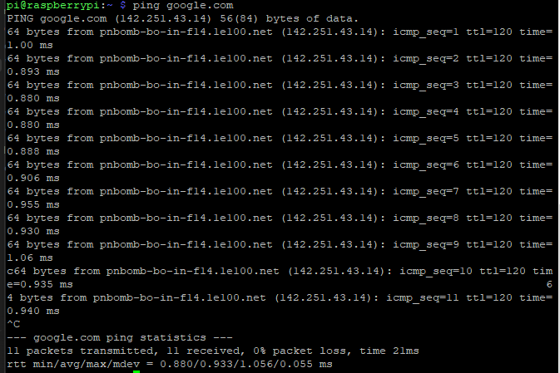

27. hostname
Description: Shows device name.
Example: hostname
📸 Screenshot:
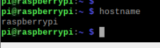

28. ifconfig
Description: Shows IP & network info.
Example: ifconfig
📸 Screenshot:
